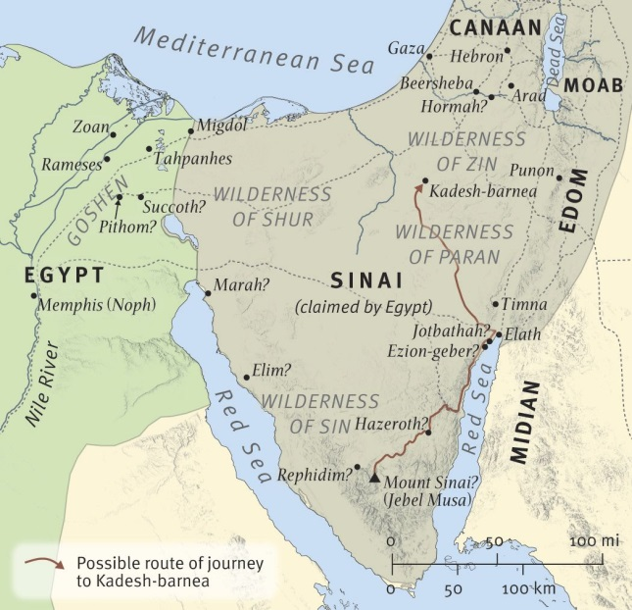
Map #1
Map #2
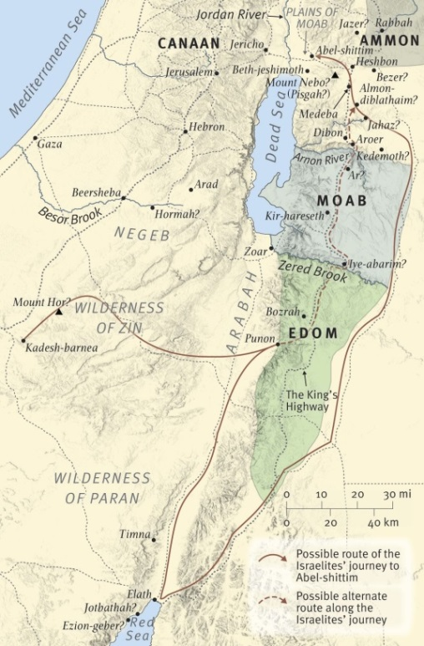  Map #2 |  | 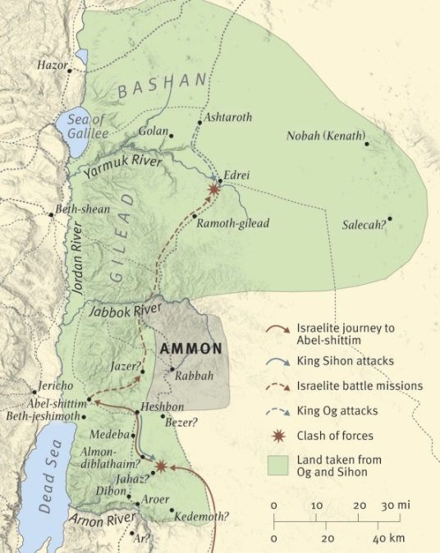  Map #3

Reading Schedule

Week 1 Monday, Sept 9 Deut 1:1-5

Week 2 Monday, Sept 16 Deut 1:6-3:29

Week 3 Monday, Sept 23 Deut 4:1-40
Break from Bible Study for 1 week

Fellowship in the Gospel Women’s Conference
“Complete in Christ”
October 11-12

Register at fgcon.org

Week 4 Monday, Sept 30 Deut 4:41-6:25

Week 5 Monday, Oct 7 Deut 7:1-11:32

Week 6 Monday, Oct 21 Deut 12:1-13:18

Week 7 Monday, Oct 28 Deut 14:22-15:23

Week 8 Monday, Nov 4 Deut 16:18-17:20

Monday, September 9, 2019
Read Deuteronomy 1:1-5
- This opening text is often called the Preamble. It has some similarities with the opening of a New Testament epistle. Just from verse 1, note (a) who is the speaker, (b) who is the audience, and (c) where is the location of the speaker and audience as they come together.

- Horeb (v2) is another name for Mount Sinai. What major event in Israel’s history took place there?

- What is the significance of the Jordan River? Why do you suppose Moses twice mentions that the people were “beyond the Jordan” (vv1,5)? Hint: It’s the same reason he further describes them being “in the wilderness” (v1) or “in the land of Moab” (v5)

Week 1 (Continued)
- Locate the lands of Sihon and Og on Map #3. They were Amorite kings that Israel defeated (v4; see Numbers 21:21-35 for the full story). Why would this fact be recounted before entering the Promised Land?

- Why might Moses have given the time marker, “in the fortieth year” in v3? Hint: Read Nu 14:31-35.

Notes:

Monday, September 16, 2019
Read Deuteronomy 1:6-3:29
- Look at 1:6-11. Identify the promises God has kept (that are described in these verses).

- Bonus Question: When did God make these promises originally (and to whom)?

- Another Bonus Question: In 1:13ff, Moses calls for the appointing of leaders and judges who would serve under him. Why couldn’t Moses judge/lead the nation by himself?

- In 1:5-7, God told the Israelites to do something.
- In your own words, what was the command?

- Did they obey? Explain and provide verse references supporting your answer.

Week 2 (Continued)
- Look at 1:19-33 (Cf. Nu 13). Let’s talk about the spies.
- Why did they send spies into the Land?

- What was the report about the Land itself?

- What was the report about the people of the Land?

- When fear came over them because of the Canaanites they would have to fight, what did Moses tell them to give them courage?

Bonus Question: What did he point to about God’s faithfulness to them in the past (Hint: 2:26-3:22 describes it in detail).

- As a result of Israel’s refusal to enter the Land, who did God say was able to go in and take it later (and who was forbidden to do so)? See 1:34-40.

Notes:

Monday, September 23, 2019
Read Deuteronomy 4:1-40
- Last week, we saw how Moses encouraged Israel to enter the Land. He did this by arguing that the Lord had been with them in past victories (see 1:29-31). At the beginning of our text, Moses takes a different tactic in 4:3-4 (referencing what God’s action in the past, see Nu 25). Explain how Moses is arguing for their obedience.

- Look at vv5-8. What is another reason Israel should obey God’s laws? Do you know of any New Testament passages that have similar reasoning for the church to be obedient?

- How and why did the Lord appear to the Israelites? vv9-14

Week 3 (Continued)
- Look at vv15-28. Explain from the text, why Israel should not make idols to worship.

- What explicit statements are made about the Lord’s character (i.e., what the Lord is like). Provide verses references.

- In the last section, Moses lists ways in which God has interacted with Israel that was unique (as contrasted with the other so-called “gods”). Why has done this? Use the text to support your answer.

Notes:
Monday, September 30, 2019
Read Deuteronomy 4:41-6:25
- Scholars have recognized that Deuteronomy is written in the style of ancient treaties between a conquering king and a conquered king who is now subject to him. Typically, the treaty began with a listing of the accomplishments or victories of the conquering king. Do you see this pattern in 4:44-49)? Explain.

- Ancient treaties also listed the duties of the people who were now in submission to the great, conquering king. What duties are seen in our text? Support your answer with verse references.

Week 4 (Continued)
- Does disobedience ever affect other people or generations? Explain and provide verse references to support your answer.

- Where in our text do we see the need for a mediator – i.e., someone to go between God and man? Explain this need.

- Read 6:4.
- How would submitting to this truth make Israel different?

- Was this truth meant to shape the current generation or future generations of Israelites as well? Explain.

Notes:
Monday, October 7, 2019
Read Deuteronomy 7:1-11:32
- The Lord promised to give the Israelites the land of many other nations (7:1). How were the Israelites to interact with those nations afterwards? Explain why?

- How did Israel become God’s people?

Week 5 (Continued)
- Read 7:9. God’s is faithful to love what kind of people?

Follow Up Question: Does your answer sound like salvation by grace or salvation by works? Explain.

- Read Chapter 8. In what ways was the Lord gracious to the people when they were in the wilderness?

- Does it surprise you that God was gracious as He punished them? Explain.

- Where else in the Bible do we see God’s mercy to people, even in His judgment?

Week 5 (Continued)
- At the beginning of Chapter 9, the Lord promised to go before the people and bring them victory in the Land. In v4, the Israelites are warned to not think this will be done by God based on their righteousness (i.e., as a reward for Israel’s obedience/faithfulness). What reason(s) does Moses give that they should not think themselves righteous?

- In 10:12-13, Moses again tells the people they are to obey the Lord’s commands completely. What reasons does he provide in the verses that follow that make such obedience right?

Notes:
Monday, October 21, 2019
Read Deuteronomy 12:1-13:18
- List all of the ways in which the Israelites are to act toward the worship places of Canaanites they are displacing.

- What should be the attitude of the Israelites as they worship? Provide support from the text for your answer.

- List the ways in which the Levites are to be cared for during worship?

- Why don’t they care for themselves?

- What do you think the ultimate reason is that the Lord wants the Levites to be taken care of?

Week 6 (Continued)
- Read 12:29-13:18
- List the different ways in which the people might be tempted to worship the idols of the Canaanites from whom they are taking the Land.

- Describe the punishment for each person/people responsible for tempting others to idolatry.

- What might keep the people from doling out that punishment?

Notes:

Monday, October 28, 2019
Read Deuteronomy 14:22-15:23
- What purposes do you see in the requirement of a tithe? Support your answer from the text.

- Read 15:1-6. How were the needy to be provided through 7-year release?

Extra Credit Question: How is the prohibition of borrowing (v6) related to this?

Week 7 (Continued)
- Read v4 and v11 about the poor. They sound like they conflict with each other. Explain why they do not.

- Why might an Israelite be tempted to refuse a loan to a poor brother Israelite?

Follow-Up Question: Why should an Israelite loan to a poor brother regardless of whether the 7-year release is near?

Notes:

November 4, 2019
Read Deuteronomy 16:18-17:20
- Read 16:18-20. Once judges or other officials are appointed what perversions of justice are forbidden?

Follow-Up Question: Summarize in your own words the effects of bribery.

- How does Moses convey the importance of following the decision handed down by a judge (or priest)?

Week 8 (Continued)
- Read 17:14-17.
- Is this a mandate for a king to be selected by the Israelites? Explain.

- What are the prohibitions for a king who would rule over Israel?

- Why is the king to make a copy of the Law? See vv18ff

Bonus Question: Why would it be important that the king’s “heart not be lifted up above his brothers”? (v20)

- A Final Question: Look back at 16:21. What principle do vv21-22 teach?

